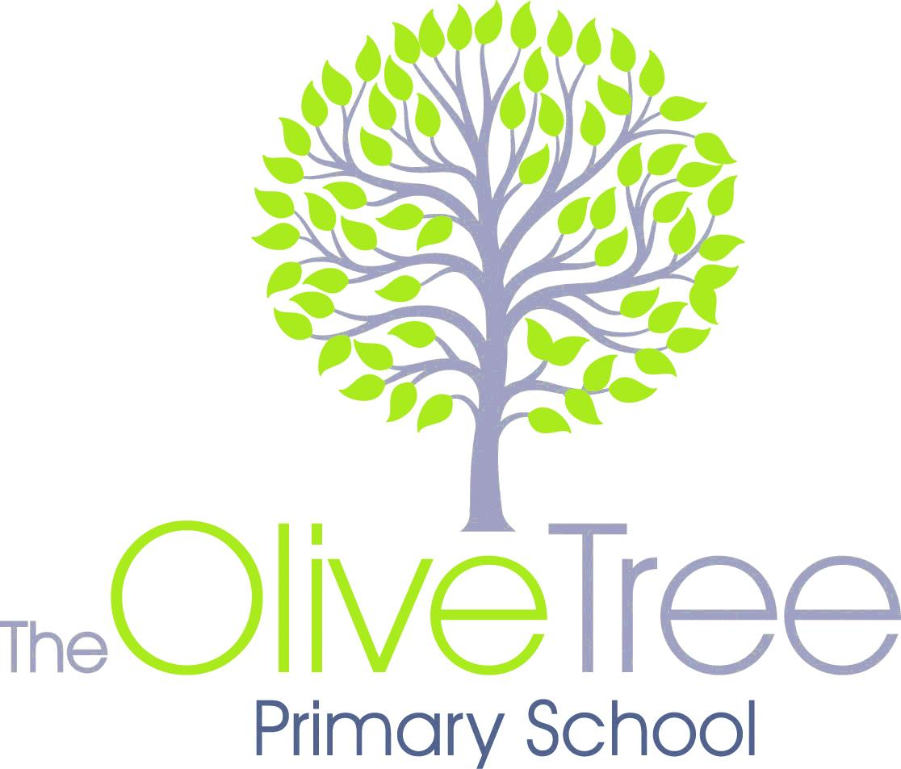

**Reception WYN2K Grid to Parents 2018-19**

**Personal, Social, Emotional Development**

We will be focusing on children as individuals, finding out their likes and dislikes, favourite foods, hobbies etc.

We will also be encouraging children to talk about their families, friends and any people who are important to them and how they make them feel?

We will talk about other people we know, bring out any similarities and differences; what we have in common with them and what is different about us?

**Understanding of the World**

We aim to make a “Me on the map” globe, which will include making a house with doors and windows that open and fill them photos of family and friends.

We will make a puzzle of ourselves by printing a photo of ourselves onto card and cutting it into pieces.

During circle time we will be sharing our favourite activities at school and at home. We will be looking at similarities and differences between the children in the class; What do we eat? What toys do we have? What languages do we speak?

**Expressive Arts and Design**

We aim to make a “Me on the map” globe, which will include making a house with doors and windows that open and fill them photos of family and friends.

We will also make a puzzle of ourselves by printing a photo of ourselves onto card and cutting it into pieces to form a jigsaw puzzle.

**Other News or Information:**

Starting Stimulus: Self portraits

Finale: Family Tree Showcase

w/c 24thth September 2016: **8:40-3:20**. All children will be fulltime.

Meet the Teacher Meeting: 24th September 9:00

Please could you ensure your children are in correct uniform everyday.

Please also send in labelled PE kits and book bags. Thankyou.

**Literacy**

**Reading**

We will be reading various books relating to our theme throughout the half term. We will then ask the children to find their favourite books to share with everyone.

**Writing**

We will be using plastic letters and templates for the children to use for their own names and names of their family and friends. We will do letter rubbings and then cut out each letter and stick them to a piece of coloured paper to spell our names. We aim to make a topic book all about ourselves; likes, dislike, eye colour, hair colour etc.

**Arabic**

We will be learning the nasheed; One Big Family by Maher Zain.

We will be learning the snack and milk duas.

**Maths**

We will be working on our numbers till 10- recognising numerals and their names to begin with.

Once children are able to write the names of loved ones and themselves, we hope to organise these in to groups according to the numbers of letters in them.

We aim to draw around our hands and feet, cut them out compare and organise them in size order. We will be introducing nursery rhymes such as “I have 10 little fingers” and “1 finger, 1 thumb, keep moving.”

**Our Theme unit this half term is:**

**All about me**

**Home Sweet Home**

**Physical Development**

We will be encouraging children so they are familiar with the layout of both reception classrooms as well as outdoor provisions. We will also be encouraging children to speak to each member of the reception team so they are able to voice their needs confidently such as using the toilet, drinking water and having snack. We will be working on children’s spatial awareness as well as their pencil control over the next few weeks.

**Communication & Language**

We will be introducing new words to the children such as; like, dislike, family, friends, belonging, home and myself.

We will sing songs about our feelings, our bodies and ourselves for example; “Head, shoulders, knees and toes” “If your happy and you know it…”

We will read various stories about people, jobs they do, hobbies, emotions and families.

**ICT Skills**

We will be introducing the children to the different technological toys, which we have in school such as the remote control cars and the Beebots. We will be using them to travel to different places. We will be using Showbie to upload our work.