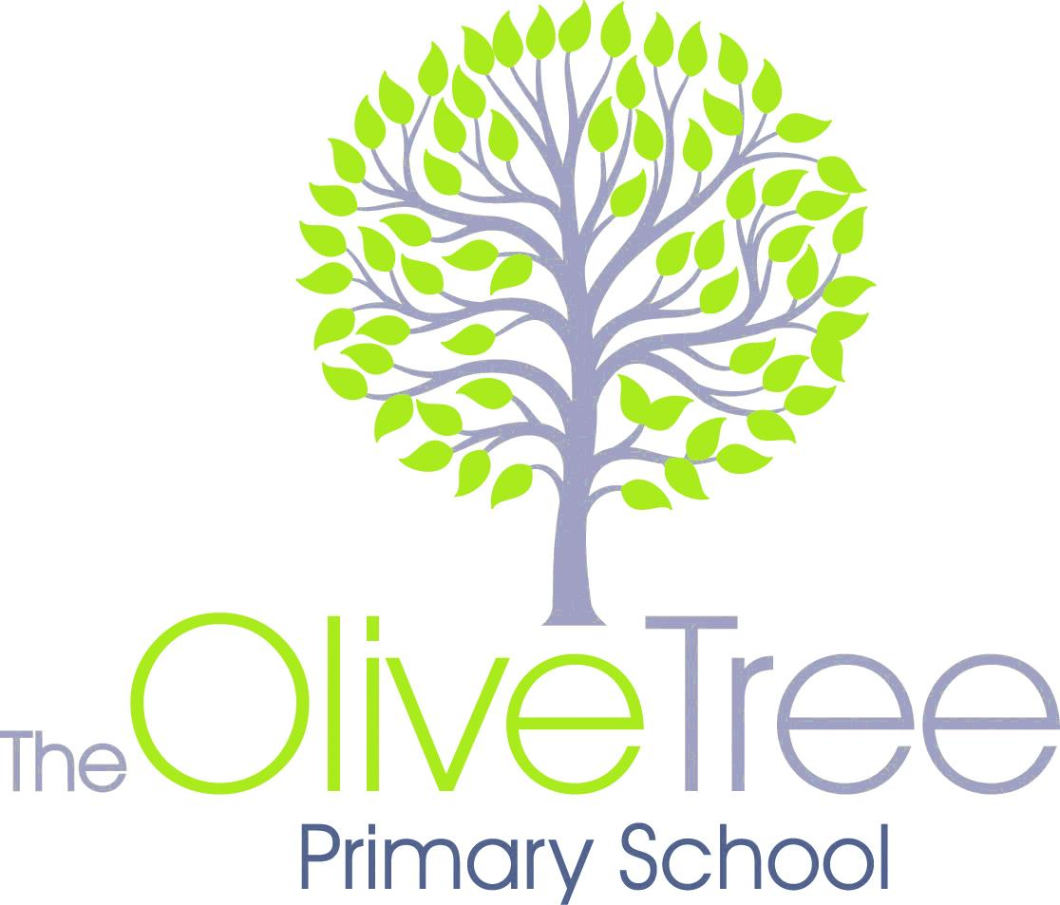

**Reception WYN2K Grid to Parents 2019**

**Expressive Arts and Design**

We will create pictures using a range of different materials to make collages, thinking carefully about why we are using a particular colour. We will be making up our own stories ad creating props to help us act out these with our friends.

**Personal, Social, Emotional Development**

We will be learning to take turns, think and talk about feelings and friendships. We will be discussing morals some of the stories might have, talk about actions of characters and possible consequences.

**Understanding of the World**

We will learn about traditional tales from different cultures and compare similarities and differences. We will be discussing the location of different stories and what we like and dislike about them.

**Communication & Language**

We will be retelling the stories we learn through acting and to small groups. We will talk about characters, actions and feelings.

**Physical Development**

We will be using the large apparatus to develop our skills of moving in different ways. We will also be developing our fine motor skills to help us write our letters clearly.

**ICT Skills**

We will develop our Maths and Literacy skills on a range of Apps using our iPads in the classroom.

**Maths**

We will be counting, sorting, ordering, begin to measure using non-standard units such as hands and feet. Additionally we will continue to learn to add and begin to take away. We will also be learning about money to help run our own sweet stall?

**Literacy**

**Reading**- continuing phonics, guided read and home reading on a daily basis. We will be blending to read words and sentences. We will also be looking at non-fiction books.

**Writing-** we will be writing shopping lists, invitations, recipes, ‘wanted’ posters, writing speech bubbles and developing mark making outdoors.

**Other News or Information:**

**Starting Stimulus:** A visit to the Library

**Finale:** Teddy Bears’ Picnic

**Arabic**

We will be starting to learn the colours in Arabic. We will also be practicing our numbers and days of the week.

**Our Theme unit this half term is:**

**Once upon a time**